**NATIONAL INSTITUTE OF TECHNOLOGY SILCHAR**

**Cachar, Assam**

**B.Tech. IVth Sem**

**Subject Code:** CS215

**Subject Name:** Signals and Data Communication

**Submitted By:**

Name : Subhojit Ghimire

Sch. Id. : 1912160

Branch : CSE – B

1. **Consider the following function:**

$$f \left[n\right]= \left\{\begin{aligned}-2 , n< -4 \\ n , -4 ≤n<1 \\ \frac{4}{n} , 1 ≤n \end{aligned}\right.$$

**Plot the function within range [-10, 10]. Also, using same range assumption and “sub-plot” function, plot the following,**

1. **f [2 – n]**
2. **f [2n]**
3. **f [n/2]**

* **AIM: To PLOT AND SUBPLOT THE GIVEN FUNCTIONS UNDER CERTAIN CONSIDERATIONS.**

**THEORITICAL BACKGROUND:**

**Plot:** A plot is a graphical technique for representing a data set, usually as a graph showing the relationship between two or more variables.

**Sub-plot:** A subplot divides the current figure into rectangular planes that are numbered row-wise.

**METHODOLOGY:**1. The variable x, for which the function is to be plotted, is defined by specifying the range of the values for x.  
2. The function y = f(x) is defined.  
3. The plot command, plot (x, y) is then called.  
4. Similarly, to subplot a function, the command, subplot (x, y) is called.

**CODE:** f = 1:21;

i = 1;

for x = -10:10

if (x < -4)

f(i) = -2;

elseif (x >= -4 && x < 1)

f(i) = x;

elseif (x >= 1)

f(i) = 4/x;

end;

i = i + 1;

end;

subplot (2, 2, 1);

stem (-10:10, f);

grid;

xlabel ('n');

ylabel ('f[n]');

i = 1;

for x = -10:10

if (x > 4)

f(i) = -2;

elseif (x <= 4 && x > -1)

f(i) = -x;

elseif (x <= -1)

f(i) = -(4/x);

end;

i = i + 1;

end;

subplot (2, 2, 2);

stem (-8:12, f);

grid;

xlabel ('n');

ylabel ('f[2-n]');

i = 1;

for x = -10:10

if (x < -2)

f(i) = -2;

elseif (x >= -2 && x < 1)

f(i) = 2*x;

elseif (x >= 1)

f(i) = 2/x;

end;

i = i + 1;

end;

subplot (2, 2, 3);

stem (-10:10, f);

grid;

xlabel ('n');

ylabel ('f[2n]');

i = 1;

for x = -10:10

if (x < -8)

f(i) = -2;

elseif (x >= -8 && x < 2)

f(i) = x/2;

elseif (x >= 2)

f(i) = 8/x;

end;

i = i + 1;

end;

subplot (2, 2, 4);

stem (-10:10, f);

grid;

xlabel ('n');

ylabel ('f[n/2]');

**INPUT DATA DESCRIPTION:**For 21 coordinate points (range from -10 to 10, both values included) the function f is declared null at the beginning and for each condition mentioned, the function f is calculated at each coordinate point or the iteration of i.

**RESULT:**

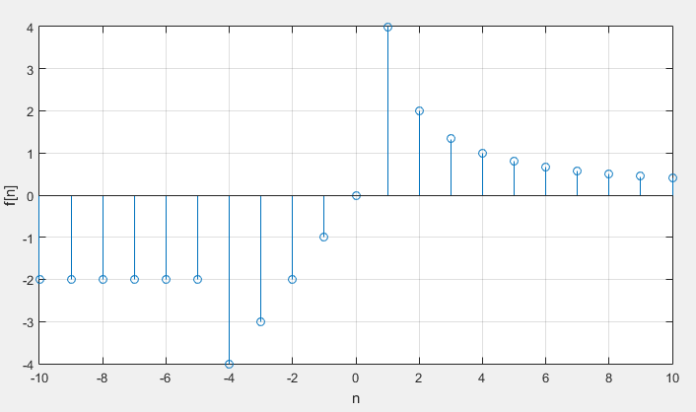

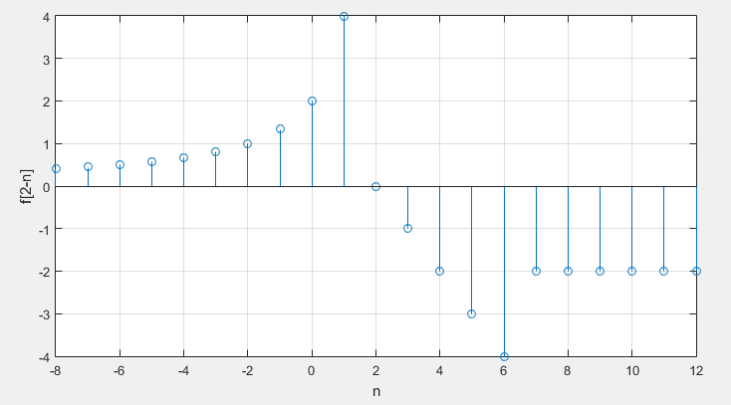

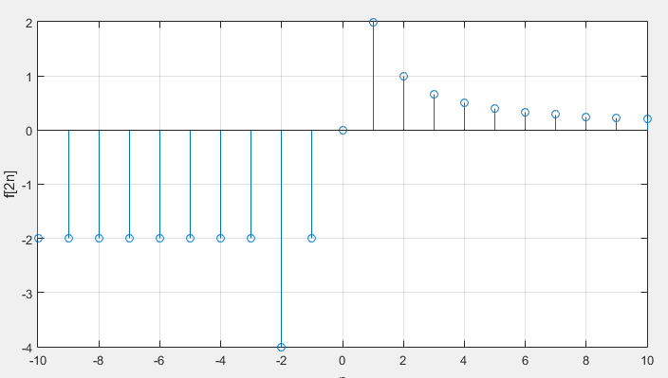

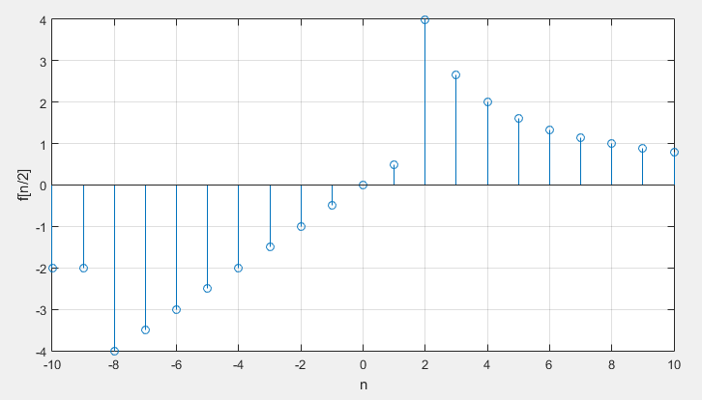

**CONCLUSION/DISCUSSION:**As it can be inferred from the obtained graphs, the range values for the provided functions remain between [-4, 4].

1. **Plot the function, x(t) = sin(t), its symbolic integration and numerical integration (using both cumulative sum and trapezoidal approximation) on the same plot for the range $\left[0, \frac{π}{4}\right]$ (both inclusive). Use different colours and line style (line, dash-dash, dash-dot-dash, dot-dot) for plotting.**

* **AIM: TO PLOT A FUNCTION, ITS SYMBOLIC INTEGRATION AND NUMERICAL INTEGRATION FOR THE GIVEN RANGE.**

**THEORITICAL BACKGROUND:**

**Plot:** A plot is a graphical technique for representing a data set, usually as a graph showing the relationship between two or more variables.

**Symbolic Integration:** It is the problem of finding a formula for the antiderivative, or indefinite integral, of a given function f(x).

**Numerical Integration:** It is the approximate computation of a definite integral using numerical techniques.

**Cumulative sums:** These are used to display the total sum of data as it grows with time or any other series or progression. This is also known as running totals.

**Trapezoidal Rule:** It is a rule that evaluates the area under the curves by dividing the total area into smaller trapezoids rather than using rectangles. This integration works by approximating the region under the graph of a function as a trapezoid, and it calculates the area.

**METHODOLOGY:**1. The variable x, for which the function is to be plotted, is defined by specifying the range of the values for x.  
2. The function y = f(x) is defined.  
3. The plot command, plot (x, y) is then called.  
4. The symbolic integration is then implemented using the ‘int’ command and the numerical integration is implemented using the ‘quad’ command.

**CODE:**

x = 0:0.05:pi/4;

fo = sin (x);

plot (x, fo, 'r-');

hold on;

syms t;

f = sin(t);

ezplot (t, int(f), [0 pi/4]);

f = cumtrapz (x, fo);

stairs (x, f, 'g--');

f = cumsum (fo);

stairs (x, f, 'b:');

axis([0 pi/4 -1.5 4]);

axis ('square');

grid;

xlabel ('n');

ylabel ('f(n)');

hold off;

**INPUT DATA DESCRIPTION:**

For the function x(t) = sin(t), three integration techniques are used, where int method defines the symbolic integration technique, cumtrapz defines the trapezoidal approximation technique and cumsum method defines the cumulative sum technique for the integrations. The scaling is taken to be 0.05 between the range of 0 and π/4.

**RESULT:**

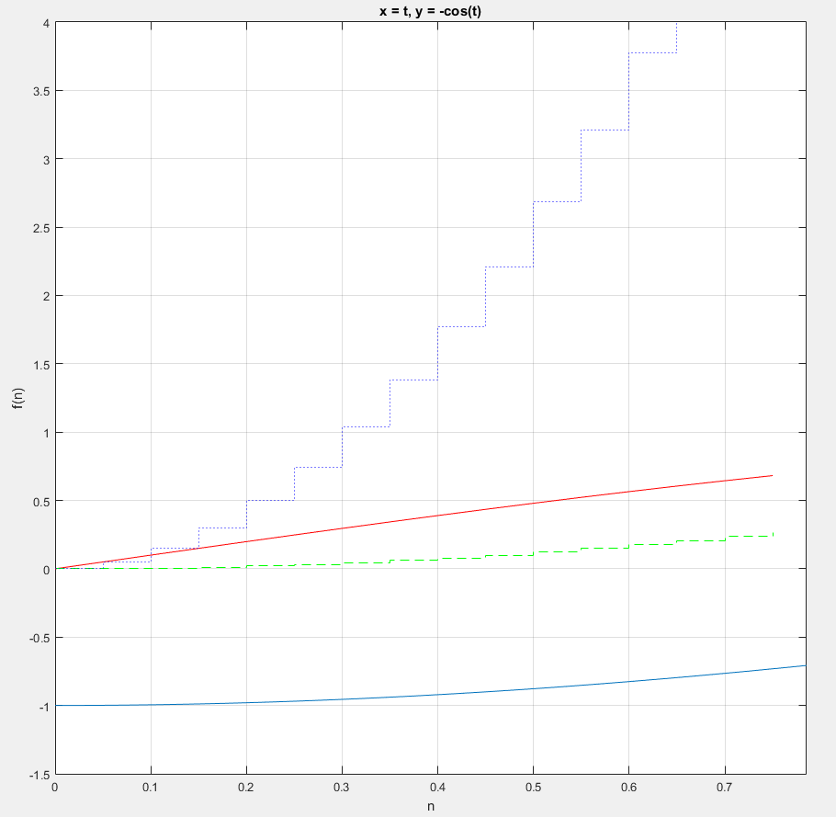

**CONCLUSION/DISCUSSION:**Comparing between all three techniques of integration, it can be inferred from the graphs that the cumulative sum techniques is the best method as it approximates integral the best.

1. **Plot the following graphs and even and odd parts of them in the same figure using “subplot” in the range of [-5, 5].**
   1. **f(t) = t (t2 + 3)**
   2. **g(t) = t (2 – t2) (1 + 4t2)**

* **AIM: TO PLOT AND SUBPLOT EVEN AND ODD PARTS OF THE FUNCTIONS FOR A GIVEN RANGE.**

**THEORETICAL BACKGROUND:**

**Plot:** A plot is a graphical technique for representing a data set, usually as a graph showing the relationship between two or more variables.

**Sub-plot:** A subplot divides the current figure into rectangular planes that are numbered row-wise.

**METHODOLOGY:**1. The variable x, for which the function is to be plotted, is defined by specifying the range of the values for x.  
2. The function y = f(x) is defined.  
3. The variables with even and odd parts are defined for the given function as xe and xo.  
3. The plot command, plot (xe, y) and (xo, y) are then called.  
4. Similarly, to subplot a function, the command, subplot (xe, y) and (xo, y) are called.

**CODE:**

clear all;  
clc;  
  
t = -5:0.01:5;

f1 = 1:1001;

f2 = 1:1001;

fo = 1:1001;

fe = 1:1001;

i=1;

for x = -5:0.01:5

f1(i) = x*(2-x*x)*(1+4*x*x);

i = i + 1;

end;

subplot (3, 1, 1);

plot (t, f1);

grid;

xlabel ('t');

ylabel ('f(t)');

i = 1;

for x = -5:0.01:5

f2(i) = (-x)*(2-(-x)*(-x))*(1+4*(-x)*(-x));

i = i + 1;

end;

i = 1;

for x = -5:0.01:5

fo(i) = (f1(i)-f2(i))/2;

i = i + 1;

end;

subplot (3, 1, 2);

plot (t, fo);

grid;

xlabel ('t');

ylabel ('Odd Parts of f(t)');

i = 1;

for x = -5:0.01:5

fe(i) = (f1(i)+f2(i))/2;

i = i + 1;

end;

subplot (3, 1, 3);

plot (t, fe);

grid;

xlabel ('t');

ylabel ('Even Parts of f(t)')

**INPUT DATA DESCRIPTION:**

For 1001 coordinate points (range from -5 to 5, both values included, with the subdivisions of 0.01) the function f is declared null at the beginning and for each condition mentioned, the function f is calculated at each coordinate point or the iteration of i.

**RESULT:**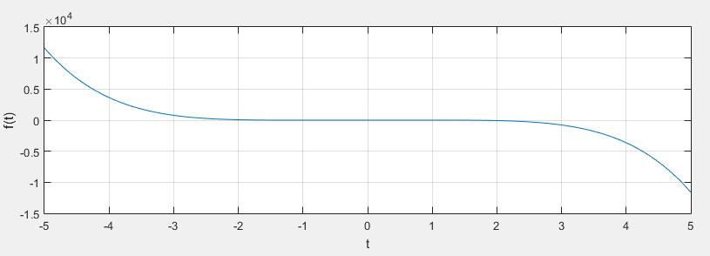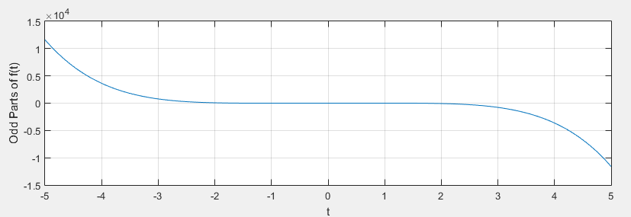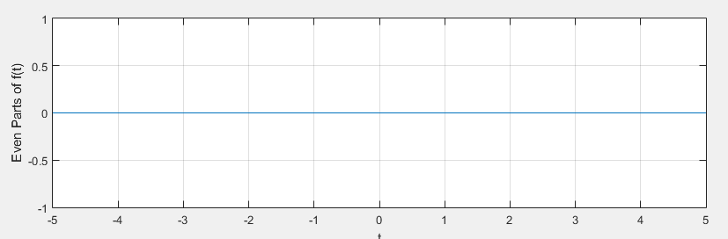

**CONCLUSION/DISCUSSION:**

Clearly, both the functions are purely odd functions, and hence their even parts are a constant zero.